- \Operation\Tube filling\Lifter\Tube filling – lifter - position
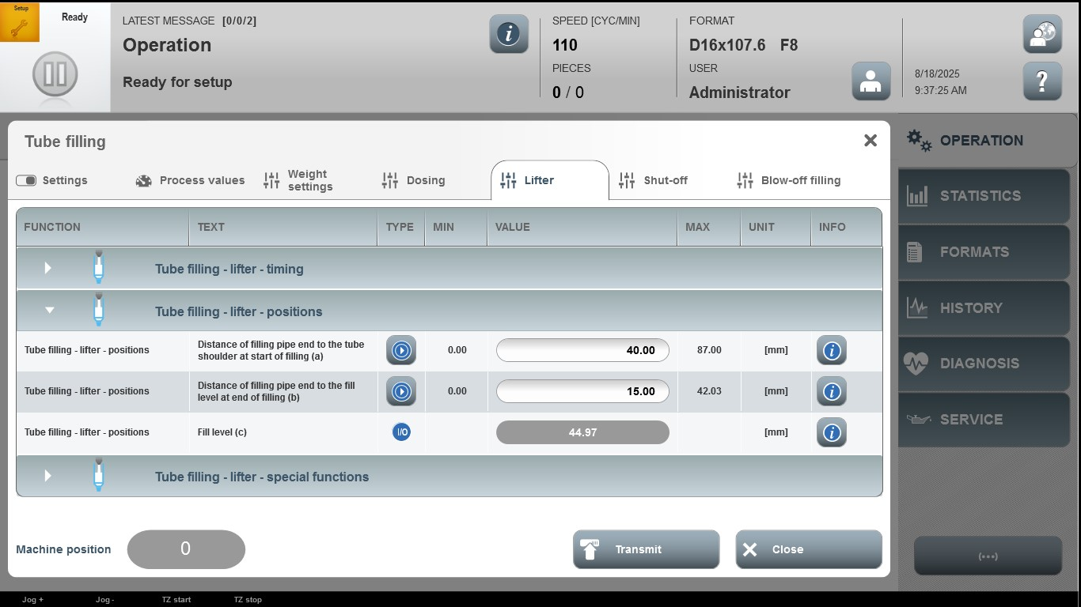

Acceptance criterion | Limits | Pass / Fail: Dev-No. | Date | Initials
Screen matches screenshot | N / A
Distance of filling pipe end to the tube shoulder at start of filling (a) | 0.00…87.00
Distance of filling pipe end to the fill level at end of filling (b) | 0.00…42.03

